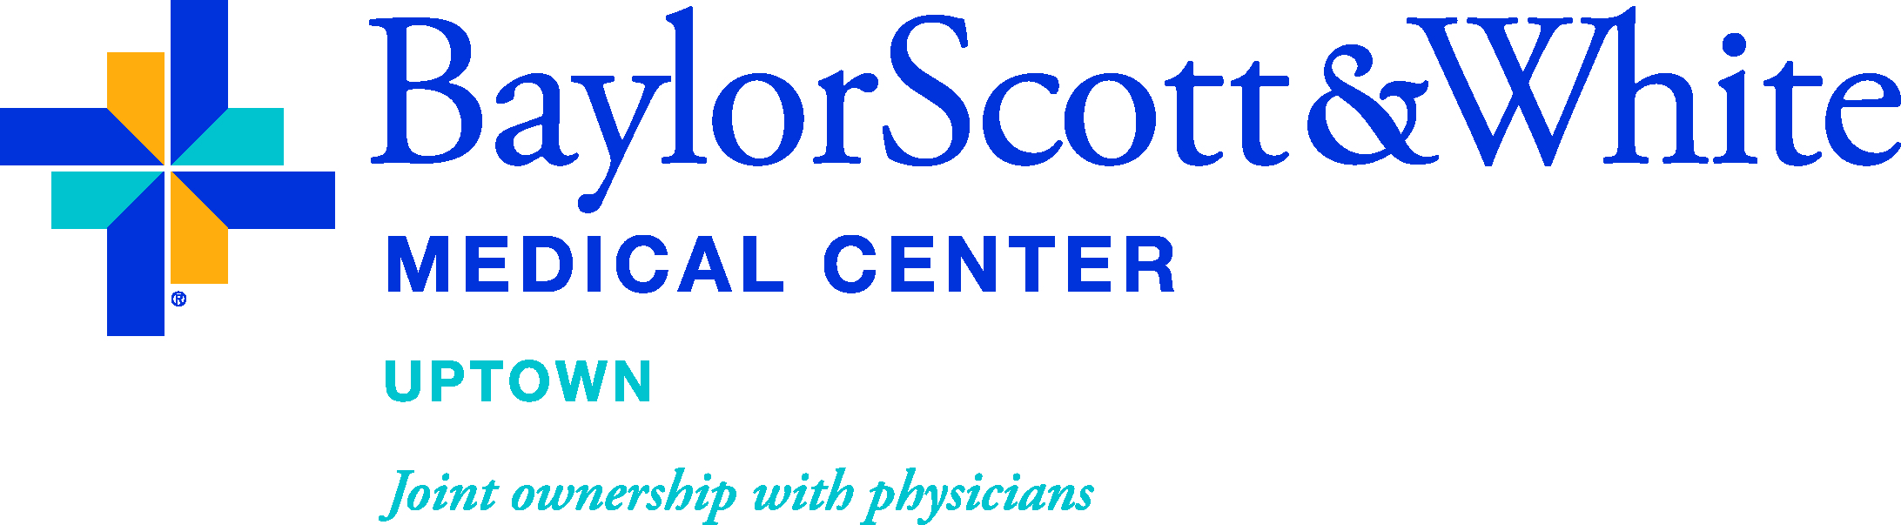

PHYSICIAN PARTNERSHIP BY SPECIALTY

ORTHOPEDIC  APPLETON, STEPHEN  BRODSKY, JAMES  FREEMAN, TANDY  FLANAGIN, BRODY  GILBERT, NATHAN  HANSEN, PHILLIP  HEINRICH, JOHN  KOGANTI, ANIL  LANCASTER, JAMES  MEDLOCK, VIRGIL  MOLLABASHY, ALLAADDIN  NEVITT, MATTHEW  QUINBY, JONATHAN  REDDY, BABU  ROYER, CHRISTIAN  ZIDE, JACOB  SPINE SURGERY  BARNETT, DAVID  BIDIWALA, SHAAD  CALLEWART, CRAIG  DUFFY, MICHAEL  JONES-QUAIDOO, SEAN  MICHAEL, CHRISTOPHER  NAFTALIS, RICHARD  RAMNATH, DEVESH  SYED, ISHAQ  VIERE, ROBERT | ENT  HARDIN, MARK  OXFORD, LANCE  GENERAL SURGERY  DAO, TUOC  LAMONT, JEFFREY  LE, LAM  STEPHENSON, JILL  PAIN MANAGEMENT  FLANAGAN, BRIAN  KONEN, ANDREW  SANDHU, NINA  PLASTIC/RECONSTRUCTIVE SURGERY  HA, RICHARD  BARIATRICS  JAYASEELAN, NIRMAL

